Cassina LC2 Armchair

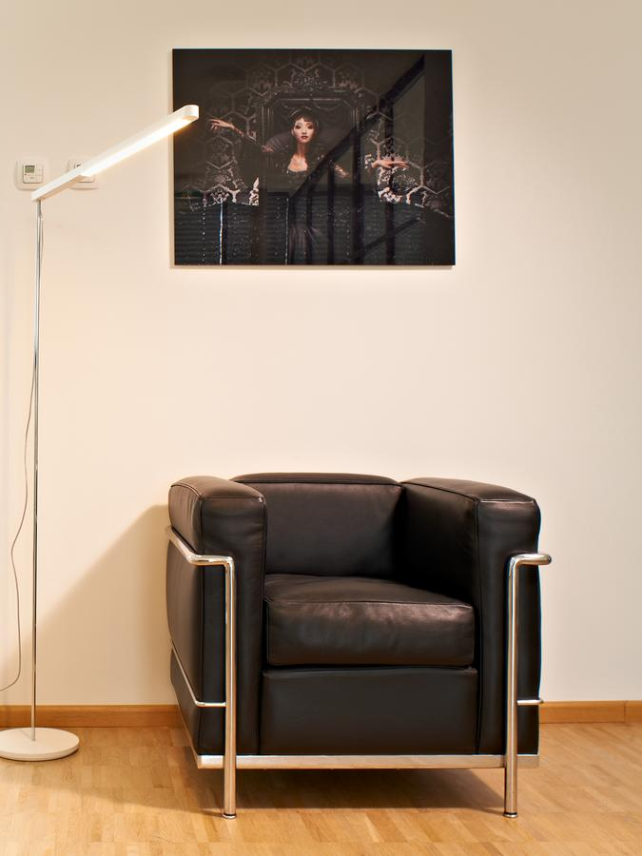

Designed by Le Corbusier, Pierre Jeanneret, and Charlotte Perriand, this iconic chair features a tubular steel frame and leather cushions. It is available in a variety of colors and finishes.